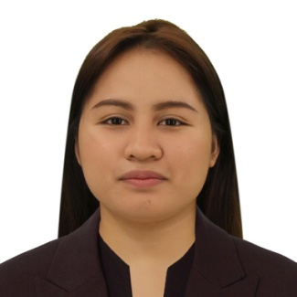

**JOEY ANNE LINDONG BULINGGAN**

Sitio Salvacion Tunasan, Muntinlupa City

Contact number: 09083247102

Email: jjjbulinggan@gmail.com

**OBJECTIVE**

Seeking for an opportunity that improve my skills and where my resourceful experience and skills will add value to organizational operation.

**PERSONAL DATA**

Age : 28 years old Date of birth : December 4, 1994

Gender : Female Civil status : Single

Citizenship : Filipino Religion : Roman Catholic

Language spoken : Filipino, English

**EDUCATION ATTAINMENT**

**Tertiary Level (2011-2015)**

Bachelor of Science in Business Administration

Major in Human Resource Development Management

Pamantasan ng Lungsod ng Muntinlupa

NBP Reservation Poblacion, Muntinlupa City

**TESDA TRAINING**

Bread & Pastry Production NCll – 141 hours July 26, 2019

**KEY COMPETENCIES AND SKILLS**

* Computer Skills, Microsoft applications (Word, PowerPoint, Excel)
* Multitasking
* Organization
* Teamwork

**WORK EXPERIENCE**

**McDonalds Petron South**

Position: Service Crew and Barista

July 26 2012 – April 2015

**AMERICAN DATA EXCHANGE - ADEC INNOVATION**

Position: Business Process Associates

April 2015 – October 2016

**SUPERBOWL OF CHINA- ALABANG**

Position: Administrative Assistant and Server

May 2017 – February 2019

**MDHM ENTERPRISE**

Service Center of Panasonic, KOLIN and LG Philippines

Position: Admin Staff

October 1, 2019 – January 4, 2020

**BPO International**

Position: Payroll Associate

January 2020 – April 2022

**Self Employed**

Home base Baker - 2019 to present

Home base Barista - May 2022 to present

*I hereby certify that the above information is true and correct with my best knowledge.*

Bulinggan, Joey Anne L.

Applicant